**ALARMS TESTING**: Create alarm in Swagger – this test will trigger an alarm in the alarm tile/widget, initiates a data collect from the monitor, initiate a notification email/text (when the user is subscribed to the customer and alarm type), and get a signal-r notification in the PRISM (bell).

1. Get locationid and customerid and Token from DEV TOOLS.
2. If emails or texts desired from alarm, be sure to subscribe your user to the customer’s alarms in USER PREFERENCES.
3. Make sure the location you are going to trigger the alarm for does not have an active alarm for the same type that will prevent to test alarm from generating the new alarm and subsequent email/text/notification.
4. Go to SQL and get the alarm definition of the alarm type you want to generate from dbo.alarms.
   1. Low Battery 1
   2. High High 2
   3. High 3
   4. Low Level 4
   5. Rain 5
   6. Low Flow 7
   7. Submerged 8
   8. Tilt 10
   9. Full Pipe 11
   10. Overflow 12
5. Open Swagger and go to ALARMS – POST api/alarms/alarm
6. Enter the customerid/locationid/alarm type/ and date.
   1. Note: The date of the alarm must be in the last 48 hours in order to trigger the email/text notifications.
   2. Date format example: 02/25/2020 04:30
7. Go to PRISM to see the alarm reported in the ALARMS widget/tile/notification:

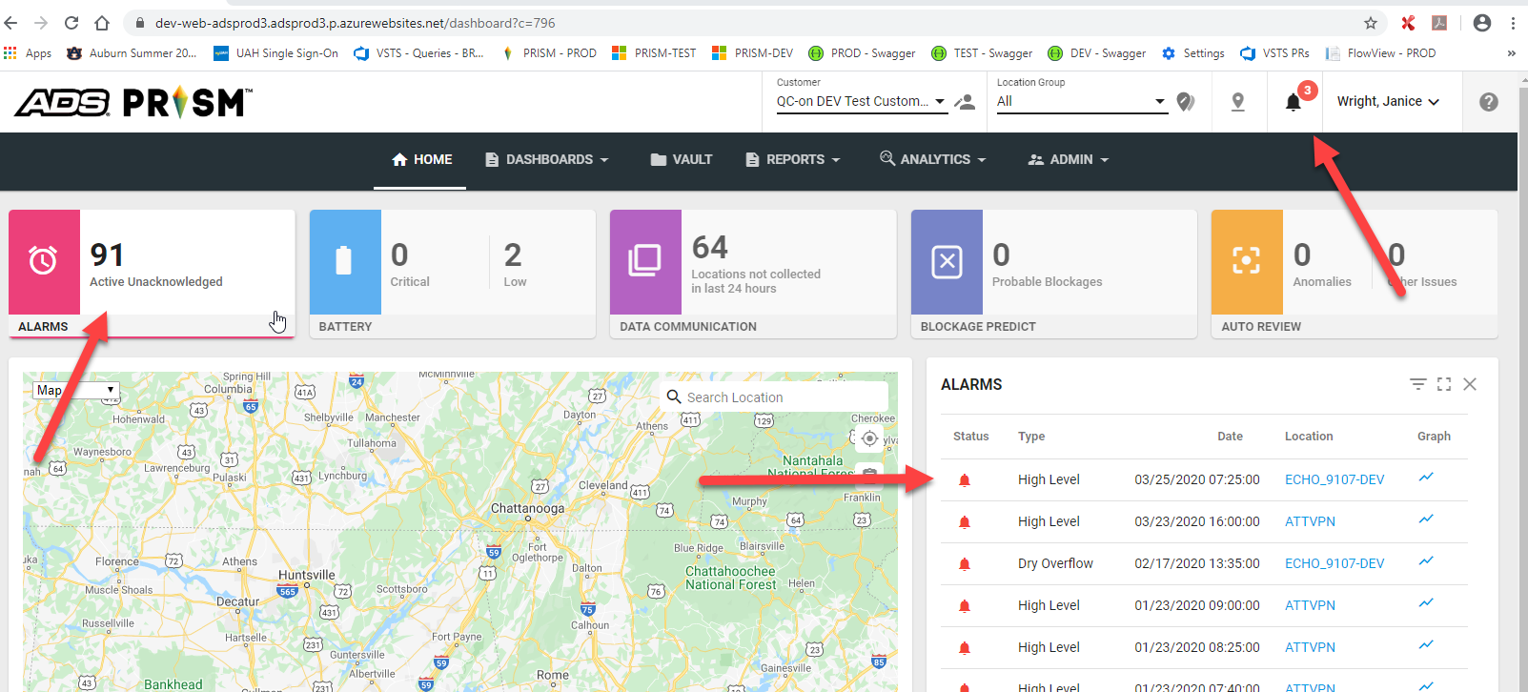

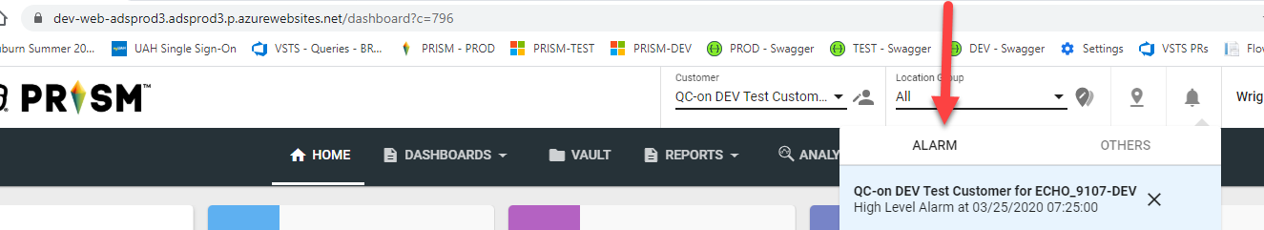

1. Open SQL, open the dbo.CommEngineInfo table and filter on the locationid/customerid, severity = 34.
2. Note the retries to get the latest data in the email notification graph (image below):

